**Humber Steering Tie/track rod modification**

Just after Christmas 2020, I was travelling from Ravenshoe to Hidden valley, via wairuna/Mt fox, and hit a major washout across the road. The track rod snapped where the thread enters the rod. Steering was lost to the passenger side of the vehicle. I was able to stop the humber but the wheels were splayed outwards. This helped slow the vehicle down. The humber stopped relatively straight. I was able to drive the vehicle the 15 km to home with just the right hand wheel steering, the left hand wheel tracked straight due to the self-centring steering geometry.

It seems that this weakness in the track rod was known to the British Army because when they developed the Humber Pig from the Humber cargo truck they uprated the track rod – just about the only change mechanically from the original truck. Note they left the tie rods (the outer rods) unaltered because they take about 40% less force due to the difference in lever length on the relay swivels.

I was unhappy to replace the broken joint with an original spec joint, and the Humber Pig joints are unobtainable. I made a very wide search of suitable joints mostly from tractors and trucks. There were two options, first from the HMMWv and also from a Mercedes truck. Both would work for the track rod, but the tie rods must have a very large angular movement due to the large suspension travel. Most truck joints would be borderline on full suspensions travel. The HMMWV has a very similar steering and suspension geometry to the humber, and need much greater travel in the tie rod end, so it was chosen.

The main problem with the original Humber joint is that the rod does not align with the centre of the ball in the joint. There is thus a major bending moment which means that if the rod is under tension (as when the vehicle hits an obstacle or washout with both wheel), the part of the rod furthest away from the cone (i.e RHS of the picture) will end up in compression, thus requiring more tension in the LHS

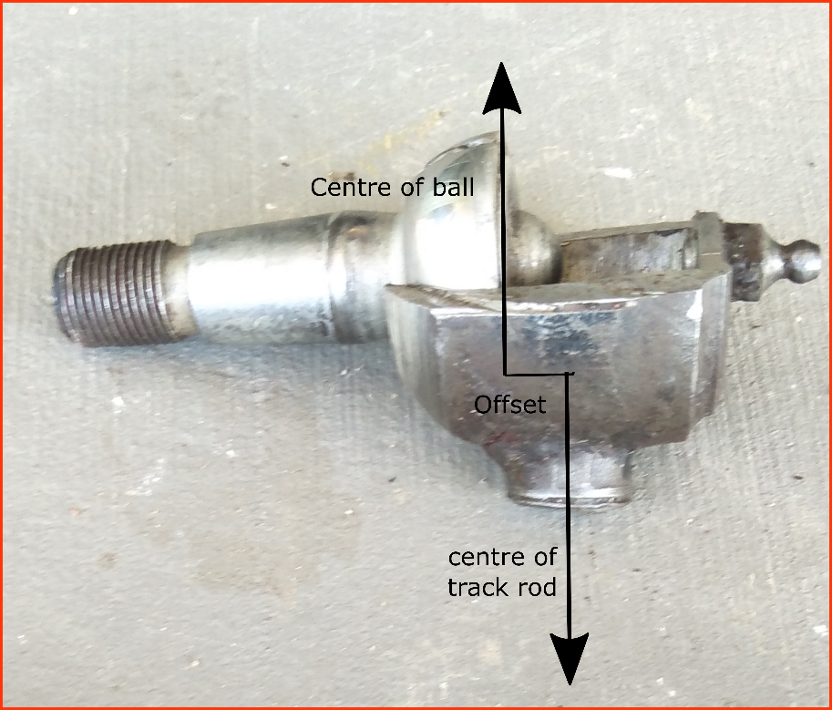

Above: Broken humber joint. The break is where the rod meets the ball outer housing. The housing has been cut to reveal the ball to demonstrate the offste of the force along the centre of the rod relative to the centre of the ball.

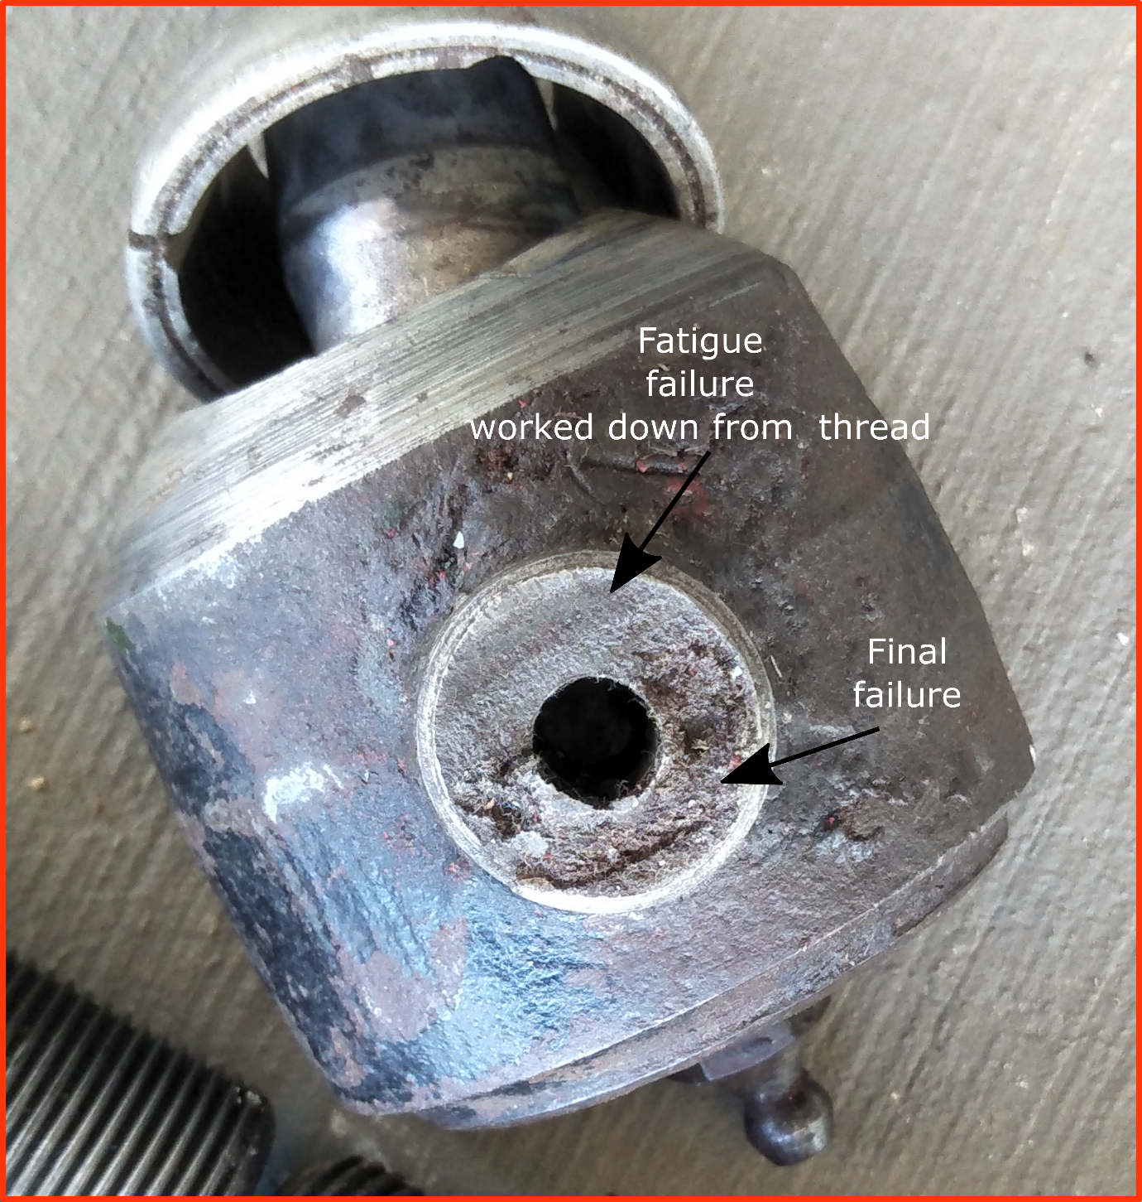

**Above: Fatigue failure of the rod.**

**Summary: Febi tie rod ends and HMMWV tie rods**

|  |  |  |  |  |
| --- | --- | --- | --- | --- |
| **Area in mm^2** | **Rod thread area**  **mm^2** | **Taper base** | **Body around ball** | **rod** |
| **humber** | **210 (6 mm hole in middle) (effectively 100 or less due to offset)** | **250** | **580** | **330** |
| **HMMWV** | **336** | **310** | **360-400** | **365** OEM  **420** if 32 mm OD which was used |
| **Febi 12974 (Mercedes and other trucks** | **400** | **310** | **380** | **600++ using 36 mm rod** |

The failure was at the 210 mm^2 rod thread which is probably effectively only about 100 mm^2 due to the bending moment. Almost all the force will be applied through one half of the rod. The HMMWV joint is at least 50% stronger, probably 250% stronger, at the thread. All other cross sectional areas are greater than the 210 mm^2 section so it makes total sense that this was where the failure occurred. The HMMWV joint is smaller than the humber around the body of the joint due to it using a smaller ball, but the HMMWV joint is better designed with a much more consistent strength around 300-360 mm^2 in all four sections.

The steering arms needed the female cones reamed to take a 1:6 (2 inch per foot) cone of the HMMWV. The Humber is a 1:8 cone. This shaves about 0.5 mm off half the cone – a very small change and insignificantly changes the strength of the steering arms.

The HMWWV joints were tested to make sure they have enough movement at full suspension and steering travel. They can take about 75 mm more travel than they will be subjected to on the Humber.

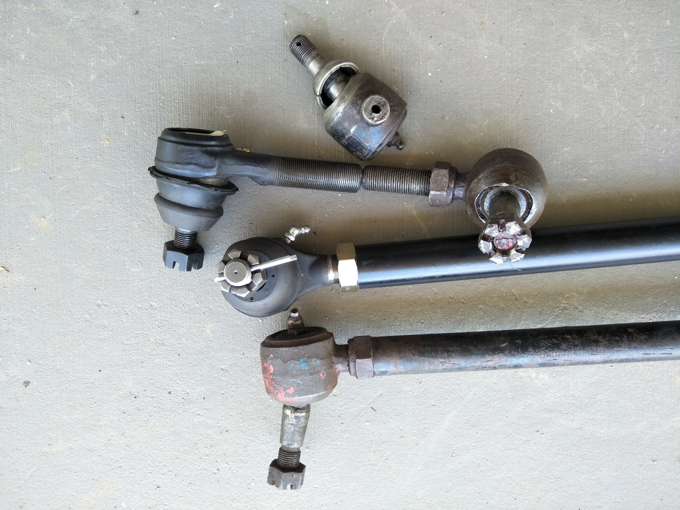

Figure Above: Top, broken humber joint. Second row: HMMWV joint and humber joint. Third row: HMMWV joint on new 32mmOD track rod. Bottom row: Stadnard Humber rod

**OTHER pieces of information, not all relevant.**

**Humber track rod end**

Humber female taper seems to be 1:8 cone. 19.2 mm at widest to 16.2 mm at narrowest over 25.6 mm length taper.

Humber tie rod taper seems to be 19.7 mm at widest to 17 mm at narrowest over 20.2 mm. Note it is only 17 mm diameter just above the ball.

There were two choice Febi- Bilstein 12974/5 or HMMWV. I chose the HMMWV as the Febi Bilsein cannot be used for the tie rods as it has insufficient angular movement.

**Febi- Bilstein 12974 and 12 975 (left and Right hand vesion) M16, M22 cone=20 mm.**

**Febi Bilstein (NOT USED)**

The cone size might be 1/10th. This picture is from a site that gives equivalent part numbers for the febi-bilstein for the 48573.

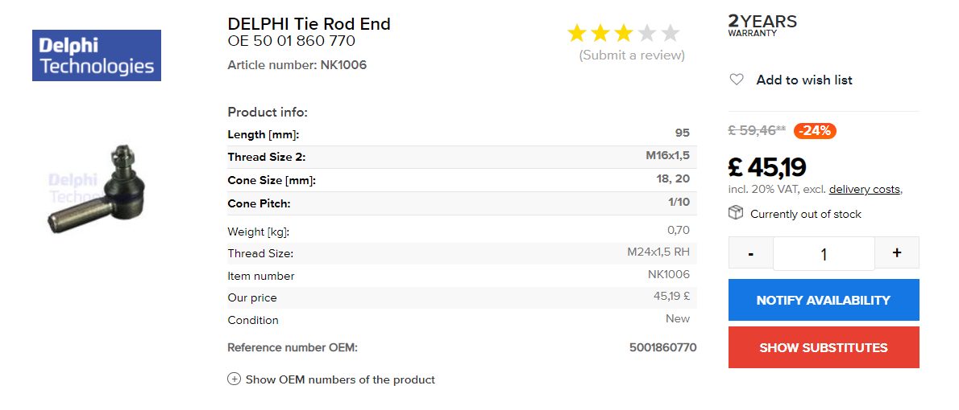

And for the 12974 also 1/10th

This is a reamer for 1:10 taper

**Tooling Station:**

Right hand thresad M24 1.5 $111 for taper, intermediat and bottom plus drill

M24 taps <https://toolingstation.com.au/shop/ols/products/3x-hss-hand-tap-set-m24-x-15-rh-taper-intermediate-plug-m2-iso-new>

The 19 mm taper on the humber Rod is about 280 mm^^2 (but only 17.8 mm just above the ball. So 250 mm^2.) (but VERY high quality steel)

The Humber tie rod threaded section (with 6 mm hole) (UNF drill size 17.4 mm) 210 mm^^2. But due to bending moment due to ball not being in line with the threaded rod its effective area is reduced TO between 40 and 50%. So effective area is about 80 to 100 mm^2.

For Febi12974 (M24 1.5) drill size is 22.5 mm so area is 397 mm^^2 (double the standard Humber rod. It also does not have a bending moment like the Humber due Humber’s thrust axis not being at the ball centre.

Humber body of joint cross section area around ball **580 mm^2 (**cf only 210 on thread**)**

Series land rover body of joint 320 mm^2 (cf 200 mm^2 on thread)

Febi12974 body of joint 380 mm^2 (cf 400 mm^2 on thread)

Old humber tube Humber tube (ID ¾ or 19 mm) OD seems to be 28 mm. So 330 mm^2

**Humber steering box (Analysis of forces and torques)**

Output shaft of electric power steering is 15 mm (nearly 17 mm on outside of spline) so can take 500Nm assuming 750MPa material such as 4140.

This goes into an annular collar of dimension 22.5OD by 17mm ID which can take 400Nm even if it was made of with very low grade steel (only 265 MPA)

Steering wheel has radius 0.24 m , SO 500 NM would require a force of 2000N (200Kg) to break the shaft.

On dirt floor the ezipower steering unit can move one wheel when it is stationary and it has an output of 75Nm, so assume that 150Nm would move both wheels. Not sure what extra load would be required to turn the wheels (when stationary) on tar road. Did rough calculation and estimate one wheel would need 1000Kg force on its tie rod, so double for 2 wheels and that would need a force of 70kg at the wheel.

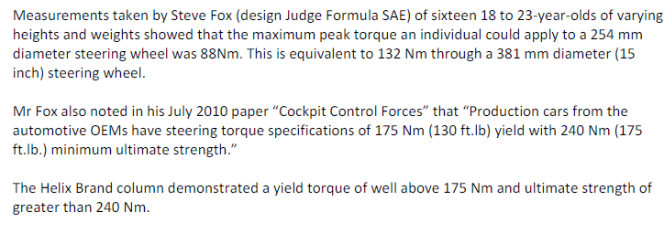

So those students applied a force of 70 kg at the wheel absolute maximum.

**Forces at various points in the system due to force on steering wheel**

**Note this will be much less than the force on the tie/track rods when hitting a big obstacle/washout**

Steering lever lengths

* Steering wheel 23cm radius
* Steering box drop arm length 17 cm
* Pivot point to steering box drop arm distance 24 cm
* Pivot point to track rod hole 12 cm)
* Pivot (to tie rod) 17 cm
* Wheel end tie rod to king pin axis (17 cm)
* Steering box ratio 21:1

Let us assume 100 kg applied at steering wheel

Force on intermediate rod (between steering box and pivot arms) 2840 kg

Force on track rod 5700kg but divide by 2 as there are two wheels, so 2850kg.

Force on tie rod 4000kg, but divide by 2 so 2000kg. (note: if the effective area of the tie rod thread is only 100 mm^2, then it can only handle 4000Kg force if it made of low grad steel (400MPa). Also note that fatigue failure, starting in the threads at the top of the joint, at forces well below yield strength is the probable mode of failure)

Torque on steering box input shaft - 240 Nm (assuming 100kg input force) (Note the electric power steering exerts 75 Nm on input shaft (see specs below) which would be equivalent to a force on the steering wheel of only roughly 20 Kg).

Torque on steering box output shaft - 4828 nm. For a 1.25 inch diameter shaft, this would need steel of 780MPa strength, i.e this is getting close to its breaking strain. If the maximum steering box input torque was applied (200Kg force, so 500 Nm) then the output shaft would be subjected to 10000Nm which would require 1600MPA steel, which is far more than even 4340 steel can handle. SO THE STEERING OUTPUT SHAFT WILL BREAK before the input shaft.

Force due to both front wheels hitting an obstacle, such a trench across the road, could be much greater on the track rods and tie rods, but have almost no effect on the intermediate rod or steering box. Hard to calculate what these forces would be, but it is possible to make a plausible calculation where the force is 4000 kg (which would snap the track rod end joint if the equivalent cross section area is 100 mm^2

**HMMWV Tie Rod ends (this is what we used)**

Due to differing lengths of the arms of the relay lever, the tie rod takes 26/36th of the force of the track rod, so 70% of the track rod. So tie rods can be 30% weaker.

HMMWV tie rods: Watch out there seem to be 2 types, one with a slight crank in the tie rod (this seems to be an aftermarket designed to allow better articulation by centring the travel (up-down) better.

HMMWV have exactly the same steering set up as the Humber. The pin axis at the wheel is vertical, the other end, the pin axis is horizontal.

HMMWV seem to have taper from 16.9 mm to 20.65 mm (0.665 inch to 0.813 inch) (*cf* 17 to 19.7 for Humber). It is a 1:6 taper (2 ft per foot, or 9.56 degrees)

Castle nut size is 5/8 – exactly the same as the Humber

Total length of tie rod (HMMWV seems to be 14.75 inches compared to 13.25 inches on Humber (min 13 inches)

HMMWV threaded rod (7/8 – 18) section 53/64 inch (drill size) which is **347 mm^2** (Febi 12974 is 400 mm^2)

HMMWV tube seems to be 1.22 inch OD (Maybe 1.25, measured off a picture) and ID 7/8 **365 mm^2**

Humber tube (ID ¾ or 19 mm) OD seems to be 28 mm. So **330 mm^2**

Humber taper pin 17.8 mm just above ball **250 mm^2** but very high quality steel.

Humber ¾ thread with hole in middle nominal **210 mm^2** but effectively half that due to bending moment from thrust axis of the ball being out of line with the threaded rod. (Febi 12974 400 mm^2)

Note HMMWV is supposed to have a wheel travel of 9 inches in standard form. From a picture the HMMWV seems to have about 18 degree movement each way

**Summary: Febi track rod and HMMWV tie rods**

|  |  |  |  |  |
| --- | --- | --- | --- | --- |
| **Area in mm^2** | **Rod thread** | **Taper base** | **Body around ball** | **rod** |
| **humber** | **210 (6 mm hole in middle) (effectively 100 or less due to offset)** | **250** | **580** | **330** |
| **HMMWV** | **336** | **310** | **360-400** | **365** OEM  **420** if 32 mm OD which was used |
| **Febi 12974** | **400** | **310** | **380** | **600++ using 36 mm rod** |

HMMWV Track rod is at least 50% stronger more like 250% due to bending moment problem stronger than Humber

The tube and taper pin are either stronger or roughly equal to threaded section. Likely very high grade steel in the pins.

For Picture Below Left HMWWV, Right Humber

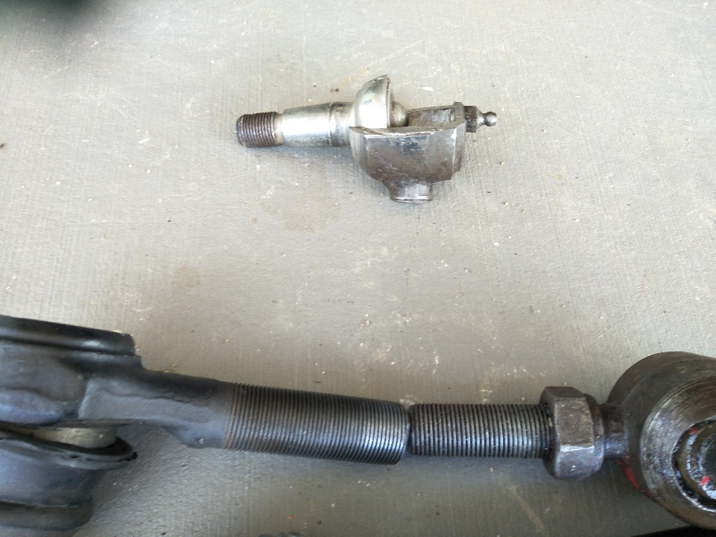

|  |
| --- |
|  |
|  |

R 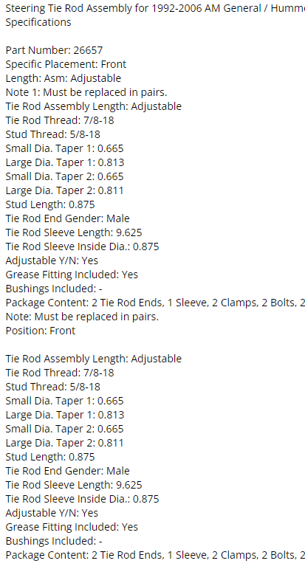

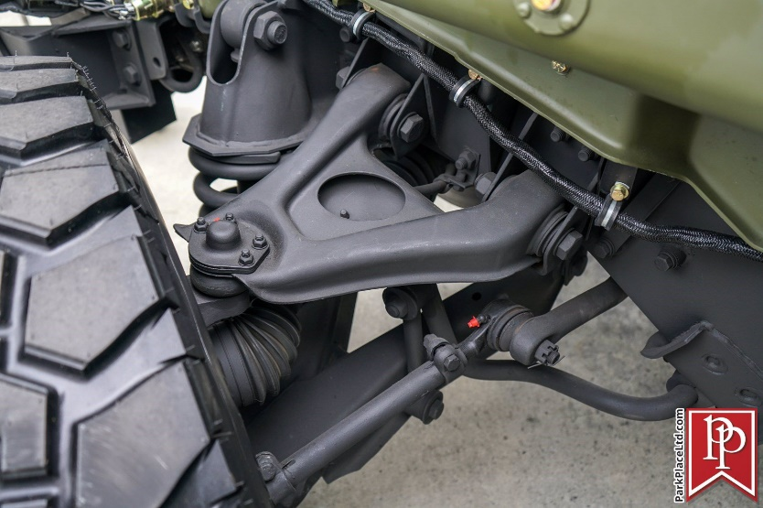

HMWWV setupH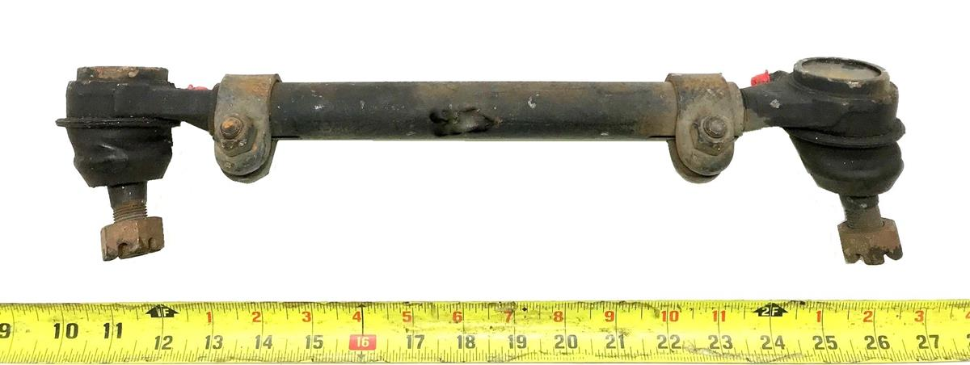

**General comments about applied forces on steering wheel**



According to flaming river steering ¾ are rated at over 350lbft

**Note the unit below seems to be the same as the EZI power steering unit made for the Humber 75 Nm assisted torque**

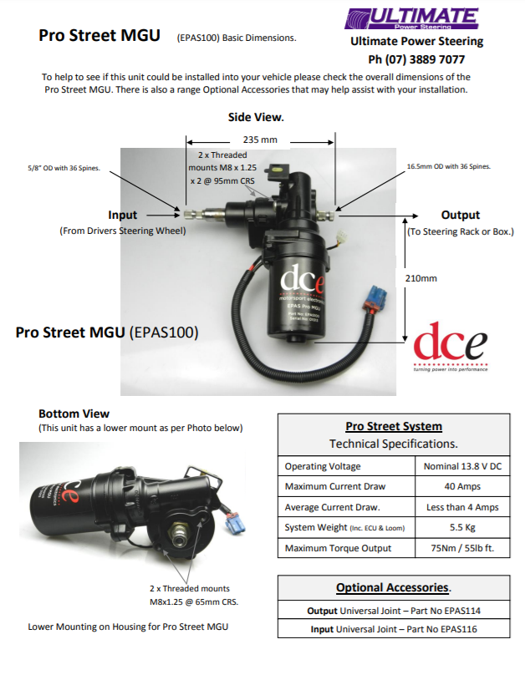

LH thread 7/8 18 aprica $130

RH from ebay used $75

Taper reamer $155 or $205

Steel $100

Total about $520